Aim
To implement a Java program that efficiently determines if an integer array contains any duplicate elements by utilizing a HashSet to achieve linear time complexity.
Algorithm
Step 1: Start
Initialize the function containsDuplicate which accepts an integer array nums as input.
Step 2: Initialize a Hash Set
Create a new HashSet of integers named seen.
Note: A HashSet is chosen because it only stores unique elements and provides $O(1)$ average time complexity for insertions and lookups.
Step 3: Iterate through the Array
Use a for-each loop to traverse every element num in the array nums.
Step 4: Check for Duplicates
For each element, attempt to add it to the seen set:
- The add() method returns true if the element was successfully added (meaning it was not already in the set).
- The add() method returns false if the element already exists in the set.
- Logic: If !seen.add(num) is true, it means a duplicate has been found.
Step 5: Immediate Return (Duplicate Found)
If the condition in Step 4 is met, immediately return true and exit the function.
Step 6: Final Return (No Duplicates)
If the loop completes and all elements have been processed without triggering Step 5, return false.
Step 7: Stop
import java.util.HashSet;

class Solution {
public boolean containsDuplicate(int[] nums) {
HashSet<Integer> seen = new HashSet<>();
for (int num : nums) {
if (!seen.add(num)) {
return true;
}
}
return false;
}
}
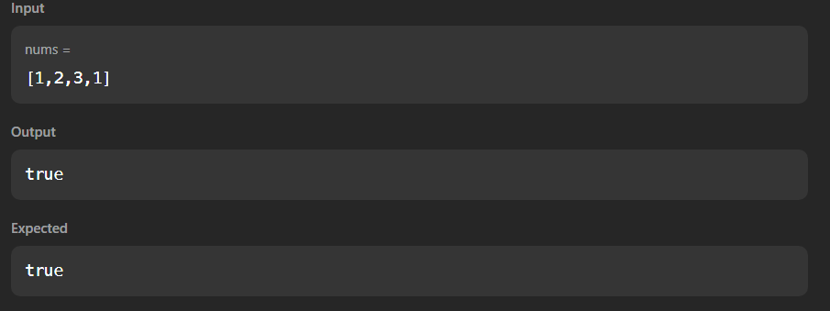

Aim
To implement a Java program that compares two sets of data points (triplets) element-wise and calculates a final score for two participants based on specific comparison rules.
Algorithm
Step 1: Start
Initialize the program and prepare for input.
Step 2: Initialize Scores
Set two integer variables, aliceScore and bobScore, to 0. These will keep track of the points earned by each person.
Step 3: Input Triplets
- Read three integers representing Alice’s ratings ($a[0], a[1], a[2]$) and store them in a list a.
- Read three integers representing Bob’s ratings ($b[0], b[1], b[2]$) and store them in a list b.
Step 4: Iterative Comparison
Loop through the indices $i$ from 0 to 2:
- Rule 1: If $a[i] > b[i]$, increment aliceScore by 1.
- Rule 2: If $a[i] < b[i]$, increment bobScore by 1.
- Rule 3: If $a[i] = b[i]$, do nothing (neither person receives a point).
Step 5: Store Results
Create a new list or array and add the final aliceScore first, followed by the bobScore.
Step 6: Output
Print the two scores separated by a space.
Step 7: Stop
Terminate the program.
import java.util.*;

class Result {
public static List<Integer> compareTriplets(List<Integer> a, List<Integer> b) {
int aliceScore = 0;
int bobScore = 0;

for (int i = 0; i < a.size(); i++) {
if (a.get(i) > b.get(i)) {
aliceScore++;
} else if (a.get(i) < b.get(i)) {
bobScore++;
}
}

List<Integer> result = new ArrayList<>();
result.add(aliceScore);
result.add(bobScore);
return result;
}
}

public class Solution {
public static void main(String[] args) {
Scanner scanner = new Scanner(System.in);

List<Integer> a = new ArrayList<>();
for (int i = 0; i < 3; i++) {
a.add(scanner.nextInt());
}

List<Integer> b = new ArrayList<>();
for (int i = 0; i < 3; i++) {
b.add(scanner.nextInt());
}
List<Integer> result = Result.compareTriplets(a, b);

System.out.println(result.get(0) + " " + result.get(1));

scanner.close();
}
}
